01. Still reflect the Airport with the hotel name. Its should be only hotel name.
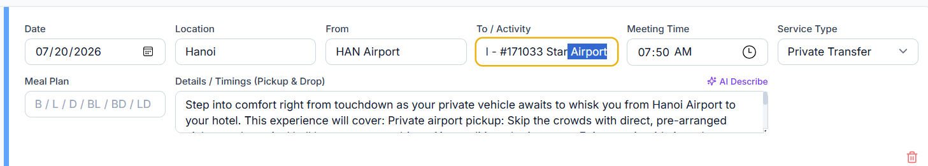

02. It’s better to mentioned flight details here instead of the detailed itinerary for only airport transfers.
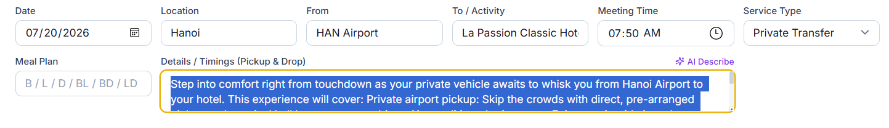

03. If itinerary have 3 separate tours for same day but still system has been captured only one tour.
Example :
1st transfer - Hanoi Hotel to Hanoi Bus Station Transfer
2nd transfer - Sapa Sleeper Bus by Inter bus Line
3rd transfer - Moana Cafe + Rainbow Slide + Alpine Coaster | Private Transfer from Sapa
04. Same description not capturing system. System captured deferent description.
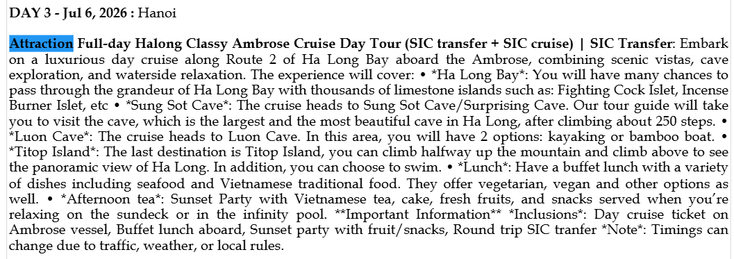

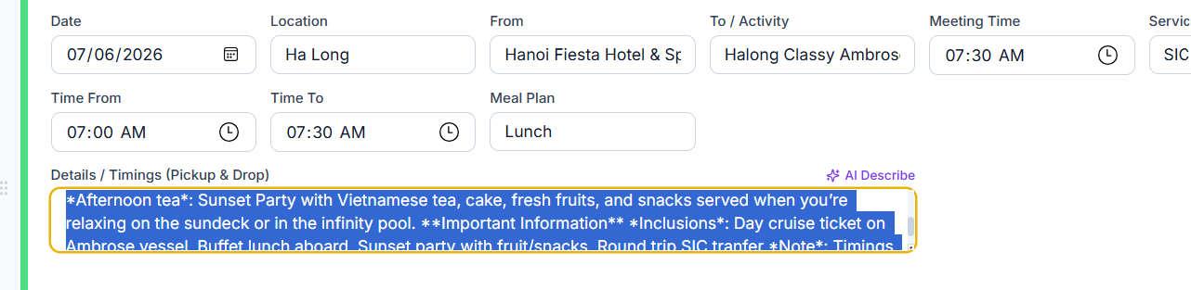

05. Itinerary mentioned tour named as “Vin Wonder & Safari Combo tickets & Grand World Transfer” but system captured only “Vin Wonder & Safari”
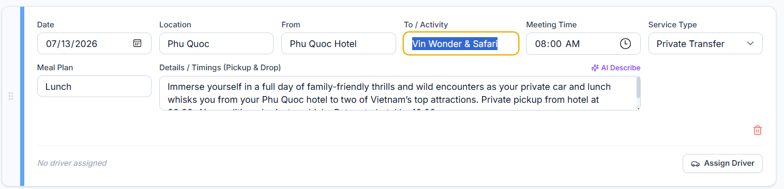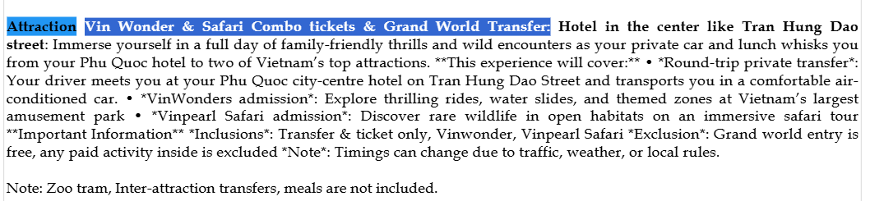

.

06. SIC tour captured wrongly captured as PVT tour in the system
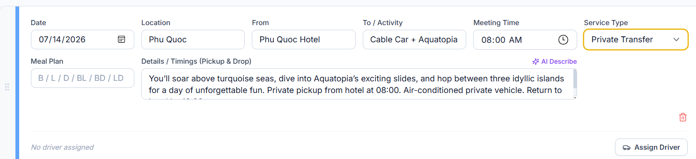

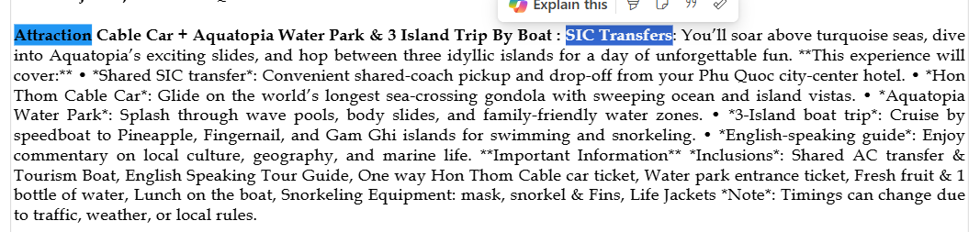
07. For the internal flight booking included departure and arrival both for internal transfers. But system captured only departure from Danang and Arrival for Hanoi transfer is missing.
1st transfer – Danang Hotel to Danang Airport – Captured
2nd Transfer – Hanoi Airport to Hanoi Hotel – Not captured

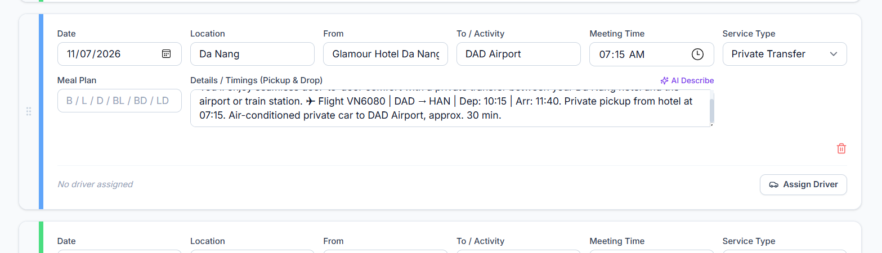

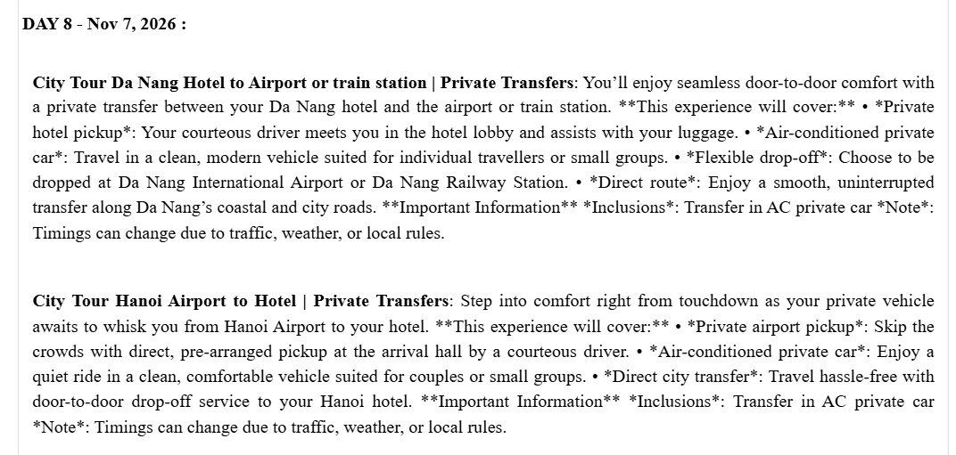

PDF GENETaing
08. Spellings wrong it should be “Private Transfer”


10. SIC Tours times mentioned as between time range as below
(07:00 – 07:30 am) in the pdf gen

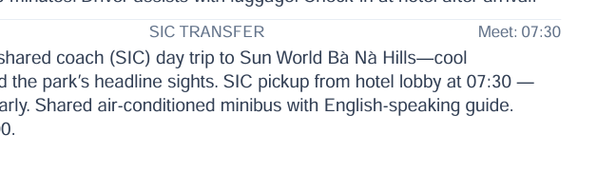

11. We cannot send the agenda to the guest below error showing
